Storage

Different Approaches for Storing GML*
A study on the effectiveness of storage models in terms of query processing. A performance study is conducted using three data sets and the experimental results are given.

GML Storage: A Spatial Database Approach
To store GML data more efficiently, an approach is proposed to store it in a spatial database.
First the schema tree is generated and then it's mapped to relational schema to store all spatial objects as values of the mapped tables' field. Spatial query can be submitted in XQuery-alike language with spatial
functional extensions, and GML query is first translated into equivalent SQL query that is evaluated by spatial database management system.

Storage GML Document: A Model-Mapping Based Approach
An approach to store and query GML, focusing on non-schema documents. First GML is parsed, the document tree is made. Then the nodes are analyzed and schema mapping is generated to store the doc in object-relational DB. Spatial and non-spatial queries are supported.

STUDY ON NATIVE XML DATABASE BASED GML STORAGE MODEL
Considering both characteristics of XML DB and GML spatial data, a native XML database based GML storage is proposed. A prototype system is developed, on the basics of JAXP (Java API for XML Processing) program API and JTS, containing schema mapping constructor, document storage tool, and spatial analyzer.
Query GML

Querying GML Documents: An XQuery based Approach
XQuery language, recommended by W3C, is only applicable to non-spatial data. To query spatial data in GML, XQuery is expanded in data model, algebra, functions and operations, and formal semantics to achieve a GML query processor. The processor can deal with non-spatial and spatial queries, and the results will be outputted in GML.
Defined data types are: Geometry, Coord, Coordinates, Point, LineString, LinearRing, Polygon, Box, GeometryCollection, MultiPoint, MultiLineString, and MultiPolygon and spatial operations are: simple geometry operation, spatial relation operation, spatial analysis operation and specific geometry operation. JTS is called for handle operations

A Specification of a Spatial Query Language over GML
Besides GML is used to represent and exchange the geographic data, it also benefits its XML-based model in interoperability, and more importantly, could be queried. In this study, the data model and algebra behind the language, based on a previously proposed model in which components and interrelations are represented as a directed graph. (The model includes new type of vertex for geometry types and its properties. Egdes represent elements containment, relationship between elements, and values.) With a data model and algebra, data types, and operation, the features that the language needs.

XQuery As a Spatial Query Language
Xquery is not a sutable language to query GML, since spatial related data types and semantics need to be treated different from XML. The purpose of this study is to define expand Xquery not for predefined GML elements, but more flexible. A set of operators and functions on GML data types that cover the most typical queries over spatial data. The difference with the previous one is that this language is applicable not for predefined GML types, but to any type.

GXQuery: A GML Spatial Data Query Language
Integration of GML and Xquery. Adding spatial data types (Point, LineString, LinerRing, Polygon, MultiPoint, MultiLineString, MultiLinerRing and MultiPolygon) and spatial operation functions (basic, relational, analysis,.. functions), based on OGC Simple Features Specification for SQL, to XQuery can achieve GML spatial data query. Moreover to the previous studies in this subject GML spatial data query language based on XQuery, problem of GML spatial data query, reasons for extending XQuery to
support GML spatial data query, features of GML spatial data query language, content of XQuery spatial extension, architecture of GXQuery, implementation methods of GXQuery, and query examples of GXQuery were detially studied and discussed.

FOR $var1 IN doc(“CDUTCampus.gml”)//Building,
$var2 IN doc(“CDUTCampus.gml”)//Building
WHERE $var1/gml:name/node() = “CDUT Palestra”
AND $var2/gml:name/node() = “CDUT Gymnasium”
RETURN geo:Contains(geo:Envelope($var1), $var2)

GML-QL: A Spatial Query Language Specification for GML
Expanding data types and spatial operation in Query:
FOR $c IN document("Country.xml") //country,
RETURN <Country> <gml:name> $c/Name/text() </gml:name>
<pop> $c/pop </pop>
<area> Area($c/shape) </area>
</Country>

Development of a Query Language for GML based on Xpath
A semantic version of Xpath language is defined, not based on the tree-based (syntactic) structure of the GML, based on the semantic structure of it.
A system is developed to store GML by PostGIS RDMS and then Xpath queries are translated into SQL, considering the GML schema. Fnaly, the result is represented in the system in KML.

XPath for Querying GML-Based Representation of Urban Maps
A system developed that stores GML by means of PostGIS, and translates Xpath to SQL.
The results would be exported into KML to be visualized.

Querying Heterogeneous Spatial Databases: Combining an Ontology with Similarity Functions
A knowledge-based approach is used to querying heterogeneous spatial databases based on an ontology and conceptual and attribute similarities. The ontology, which may be independent of the databases, expands and filters a user query. Then, queries are translated into a formal specification of entity classes, which are compared against definitions in databases. This process is carried out by determining the conceptual similarity between entities in a user ontology and by comparing these entities in the ontology with entities in the conceptual models of databases. In addition, the speciﬁcation of a query is done not only by identifying entity classes but also by considering constraints based on attribute values.

Studying an Approach to Query Spatial XML
Towards integrating spatial and non-spatial data, it's necessary to develop an integration sys. For querying the data in different sources. Here a prototype of a mediation system for querying XML spatial resources in GML is studied. The main task of this approach is to provide users with a unique interface for querying spatial XML resources with different schemas, independently of their organization and location. It provides the infrastructure for formulating structured spatial queries by taking into consideration the conceptual representation of a specific domain in the form of an ontology. The resources are integrated using RDF. The most novel and critical feature of this approach is the querying of spatial XML resources, because it uses a different way from that of querying and relating non-spatial resources.

Towards Similarity-based Topological Query Languages
Base on the problem posed in different representation of spatial data in various resources ( For example, one dataset M1 may represent roads and bridges as regions, another dataset M2 may represent roads as regions and bridges as lines, a third dataset M3 may represent both as lines), or even in integration scenarios or architectures, a possible solution is to introduce some mechanism of query relaxation, by which approximated answers are returned to the user. In this study, the relaxation problem for spatial topological queries is considered. In particular, some relaxed topological predicates are presented and is show in which application contexts they can be significantly used. In order to make such predicates effectively usable, the way that GQuery, an XML-based spatial query language, can be extended to support similarity-based queries through the proposed operators is also discussed.

Determine all roads overlapping some bridge.
for $x in document(bridge.xml), $y in document(road.xml)
where overlap($x/geometry, $y/geometry) = true
return $x

Determine all roads overlapping some bridge, up to a 22% error.
for $x in document(bridge.xml), $y in document(road.xml)
where overlapw($x/geometry, $y/geometry,R,L,0.22) = true
return $x

Integration of Spatial XML Documents with RDF
An approach to integrate Geospatial data on the Web, storing them in GML, and using a query language. An ontology is used to solve the semantic heterogeneity of different GML documents.

Other

A Library for Managing Spatial Context Using Arbitrary Coordinate Systems
Numerous coordinate systems are used commonly. Conversion between them in order to communicate, inter-operate, and integration of data between various applications and systems is a necessity. A library, using JTS, based on the OGC is developed to cope with different CSs.

Point collection partitioning in MongoDB Cluster

Multi-Criteria Path Finding
An algorithm to find the shortest path between start and end point, based on different criteria, which is compatible with database operations. The result can be stored in DB, also based on the criterias, for future use.
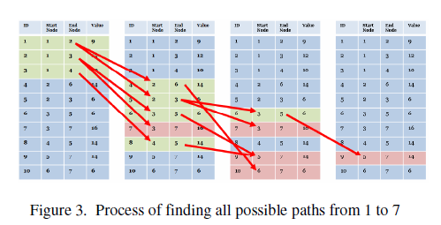

Ontology-based Geospatial Data Query and Integration**
In the geospatial data sharing, GML and data access protocols like Web Future Service (WFS) help enabling clients to access heterogeneous data. Usability of the access is limited, because of the lack of data semantics encoded in WFS feature types. new method to provide integrated access to distributed geospatial data using RDF ontology and query rewriting. This method is more efficient than converting all data to ontology instances because it avoids the costs and consistency problems of data replication. Also, ontology interface can still use existing tools for conducting spatial query on geometries and relational queries on non-spatial data, and for rendering spatial features encoded in GML. Using the proposed method, user queries can be more straightforward because the application ontology can encode data semantics not available in WFS feature types or database schemas. Our method uses RDF ontology but since RDF is a subset of OWL, the method can be directly applied to OWL ontology though extension may be needed to take advantage of the semantic constraints of OWL. OWL has more semantic constructs such as class equivalence/intersection/union, transitive/reflexive object properties, and the restrictions of universal/existential quantification on object properties. Our query rewriting algorithm needs to be extended to handle semantic constraints encoded with these constructs. However, it may be possible to use some existing tools such as Jena in this extension.

A Query-Friendly Compression for GML Document
Since GML documents are mostly in big size, a query-friendly compression method is proposed.
The GML Doc. In SAX document parsing are transformed into a compact representation, encompassing an event dictionary, the event hierarchy, a binary event tree, and the doc. Content blocks before compressed using a general compressing utility. The method supports direct path queries and spatial queries, without the requirement of a full decompresion.

Advances in GML for Geospatial Applications*
A study on GML from different views for using it in spatial applications, such as storing, querying, parsing, and visualizing. Also, using it in mobile devices and web services are surveyed.

MongoDB

Geospatial Index:

There is two special indexes in MongoDB: 2d indexes that uses planar geometry when returning results and 2sphere indexes that use spherical geometry to return results.

When an index is created, geohash values for coordinate pairs are calculated and then the geohashes are indexed.
Geohash is calculated by recursively dividing the a 2D map into quadrants and assigning each area a 2-bit value.

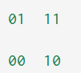

If the file contains just flat data, the 2d Index has to be used, but for those which also contain spherical data, 2sphere Index has to be chosen, since the distance function differs respectively.

Later on geohash values will be index using B-Tree.
MongoDB also used B-Tree structure for other type of index, such as Single Field (e.g. indexing over names), Compound, Text Index. (Probably this point effect on the structure of geospatial index.)

Geospatial Functions:

geoWhithin, near (flat space), nearSphere (spherical space), geoIntersect, which could be mixed with other non-spatial functions (like find, ...).
centerSphere (for spherical space), center (for flat space, define a circle with a specified radius), maxDistance (mixed with near functions to specify the demanded distance), box (defines a box, could be also mixed with geowithin function), polygon (defindes a polygon), inqueDocs (to prevent a through put a document twice in query results)

Geohash (wikipedia)
Geohashes offer properties like arbitrary precision and the possibility of gradually removing characters from the end of the code to reduce its size (and gradually lose precision).
As a consequence of the gradual precision degradation, nearby places will often (but not always) present similar prefixes. Conversely, the longer a shared prefix is, the closer the two places are.
The main usages of Geohashes are
- as a unique identifier.
- represent point data e.g. in databases.
When used in a database, the structure of geohashed data has two advantages. First, data indexed by geohash will have all points for a given rectangular area in contiguous slices (the number of slices depends on the precision required and the presence of geohash "fault lines"). This is especially useful in database systems where queries on a single index are much easier or faster than multiple-index queries. Second, this index structure can be used for a quick-and-dirty proximity search - the closest points are often among the closest geohashes.
One limitation of the Geohash algorithm is in attempting to utilize it to find points in proximity to each other based on a common prefix. Edge case locations close to each other but on opposite sides of the Equator or a meridian can result in Geohash codes with no common prefix.[1]
Secondly a geohash essentially defines a bounding box within which a location lies, therefore two locations may be spatially very close but have different geohashes. In order to be useful to proximity searches, the surrounding eight geohashes of a geohash must be calculated and the locations matching these pulled out, therefore complicating potential usage in proximity searches.

MarkLogic

Geospatial data is marked up in XML elements and/or attributes. MarkLogic could handle and query different formats, such as GML, KML, GeoRss, and even general format for geometric data which are not based on a specified format.

Geospatial Search

Overview

- Coordinate Systems

Only WGS84 and Raw coordinate systems are supported. WGS84 is used for data on the earth geometry, and raw coordinate system is suitable for data on flat plane.

- Geospatial Queries Type
The following types of geospatial queries are supported

- point query--matches a single point
- box query--any point within a rectangular box
- radius query--any point within a specified distance around a point
- polygon query--any point within a specified n-sided polygon

Additionally, there are some Geospatial Operations as built-in functions to perform operations on geospatial data (in cts namepsace):
- box-intersects → Returns true if the box intersects with a region.
- circle-intersects → Returns true if the circle intersects with a region.
- polygon-intersects → Returns true if the polygon intersects with a region.
- complex-polygon-intersects → Returns true if the complex-polygon intersects with a region.
- polygon-contains → Returns true if the polygon contains a region.
- complex-polygon-contains → Returns true if the complex-polygon contains a region.
- distance → Returns the distance (in miles) between two points.
- shortest-distance → Returns the great circle distance (in miles) between a point and an region. The region is defined by a region.
- destination → Returns the point at the given distance (in miles) along the given bearing (in radians) from the starting point.

- XQuery Primitive Types And Constructors
These constructors (as functions from search module, cts namespace) are used in geospatial queries (cts:query constructors), defining regions as instances of cts:region, then the query returns true if the searching data are inside the region.
- cts:box
- cts:circle
- cts:complex-polygon
- cts:linestring
- cts:point
- cts:polygon

- WKT

WKT language also is supported for geospatial data representation. The parse-wkt function is used when WKT is used. It converts WKT to sequence of region items. Also, cts:to-wkt function could convert cts:region type in MarkLogic to WKT.

GeoSpatial Coordinates and Regions in MarkLogic Server

Latitudes and longitude pairs shape point. Points shape other geometries, like circle or polygon. Boxes are formed by 4 points which on the surface of the Earth, the edges of the box are arcs, but when those arcs are projected into a plane, they become two-dimensional latitude and longitude lines, and the space defined by those lines forms a rectangle.

The Geospatial Index
It is not based on quad or R-tree. It works like a range index with points as data values. In this range index, every value is a pair of latitude and longitude. Like an array of x,y values, sorted mainly based on lat and then long values. The values in array also are connected to the corresponding doc.
The points would be founded easily in a sorted structure. Boxes could be found first by finding the lat range, then checking for the long range. For circles and polygon as more complex ones, the bounding box is used to find the region they belong to. Also, to check if a point is inside the polygon, the number of intersections with the northward or southward arc of the point is counted.

….

Different types of Geospatial Indexes: (???)

- Geospatial Element Indexes: data is represented by whitespace or punctuation separated element content
- Geospatial Element Child Indexes: data comes from whitespace or punctuation separated element content, but only for elements that are a specific child of a specific element.
- Geospatial Element Pair Indexes: data comes from a specific pair of elements that are a child of another specific element.
- Geospatial Attribute Pair Indexes: data comes from a pair of specific attributes of a specific element.
- Geospatial Path Range Indexes: data is expressed in the same manner as a geospatial element index and the element or attribute index is defined by a path expression.

Geospatial Index Positions
For each geispatial index there is a positions options, which is used for queries with restrictions of data distance inside the document.

Geospatial Lexicons

Provided by spatial index, containing unique values of geospatial data.

“geo” Xquery Library
geo:box | Create a cts:point value from an element representing a box in one of the supported markup vocabularies.
geo:circle | Create a cts:circle value from a radius and an element representing a point in one of the supported markup vocabularies.
geo:geospatial-query | Returns a cts:query matching points within given regions.
geo:geospatial-query-from-elements | Returns a cts:query matching points within given regions.
geo:interior-polygon | Create a sequence of cts:polygon values from a polygon element in one of the supported markup vocabularies.
geo:point | Create a cts:point value from an element representing a point in one of the supported markup vocabularies.
geo:polygon | Create a cts:polygon value from a sequence of point elements in one of the supported markup vocabularies.

“gml” Xquery Library
gml:box | Create a cts:box value from a GML Envelope element.
gml:circle | Create a cts:circle value from a radius and GML Point element.
gml:geospatial-query | Returns a cts:query matching points within given regions.
gml:geospatial-query-from-elements | Returns a cts:query matching points within given regions.
gml:interior-polygon | Create a sequence of cts:polygon values from a GML Polygon element.
gml:point | Create a cts:point value from a GML Point element.
gml:polygon | Create a cts:polygon value from a sequence of GML Point elements or a GML Polygon element.

“geoRss” Xquery Library
georss:circle | Create a cts:circle value from a radius and GeoRSS point element.
georss:geospatial-query | Returns a cts:query matching points within given regions.
georss:point | Create a cts:point value from a GeoRSS point element.

“kml” Xquery Library
kml:box | Create a cts:point value from a KML LatLongBox element.
kml:circle | Create a cts:circle value from a radius and KML Point or Location element.
kml:geospatial-query | Returns a cts:query matching points within given regions.
kml:geospatial-query-from-elements | Returns a cts:query matching points within given regions.
kml:interior-polygon | Create a sequence of cts:polygon values from a KML Polygon element.
kml:point | Create a cts:point value from a KML Point or Location element.
kml:polygon | Create a cts:polygon value from a KML polygon or a sequence of KML Point or Location elements.

“cts” Functions
Part of these functions also contain geospatial function:
----------------------------------------------------------------------------------------------------------------------------
For querying on geospatial data, after loading the data into the DB and making the indexes, primitive types should be constructed to be used in the geospatial cts:query functions. Then, geospatial queries needs to be constructed, using primitive types.
Also, there are modules to convert the Metacarta, GML, KML, and GeoRSS formats to cts:box, cts:circle, cts:point, and cts:polygon formats, to pass them into the cts:query constructors and make appropriate queries.

eXist-db

The Geospatial Index
The design if spatial index in eXist-db doesn't store character data from the document. It stores WKB index entries in a JDBC database, namely a HSQLDB. In other words, the spatial data is stored in the DB, but geometries, as JTS Geometry instances, are held in memory, waiting for a special mode to be flushed into a relational DB, insertion or removal. The Geometry WKT would be serialized and deserialized to and from the database.
The index is made by the relational db (uses an SQL database to index spatial data) and the geometric functions are applied using JTS library.

Both PostGIS and Oracle Spatial share the same “R-Tree” [1] spatial index structure. R-Trees break up data into rectangles, and sub-rectangles, and sub-sub rectangles, etc. It is a self-tuning index structure that automatically handles variable data density and object size.

Ideas

- Query general format geospatial data, considering the data as a set of points, ...
- Storing the eospatial data in geohash ???
- …

Spatial Indexing

Conventional indexes are not suitable to support the spatial data, since the spatial data complex in structure and relations, operators used for retrieval are complicated, and spatial orderings would be hard to define. Also, a point which is not be suitable for spatial objects is that they would consider the spatial objects in one dimension and do not preserve the spatial proximity.

Efficient data manipulating depends on the index structures.

Indexing Techniques

Binary-tree Based

The kd-Tree
A binary search tree structure for organizing k dimensional points. The basic idea is alternatively split the area by x- and y-coordinate, that at each level splits the points half in left and half in right and half below and half above respectively. For every non-leaf node, there is a k-th dimension discriminator, which defines the the left and right subtrees order association with this node. If the discriminator is associated to the i-th dimension, all the i-th attribute of the sub-nodes in left subtrees are smaller than this node, and all the right sub-tree nodes have the i-th attribute greater.
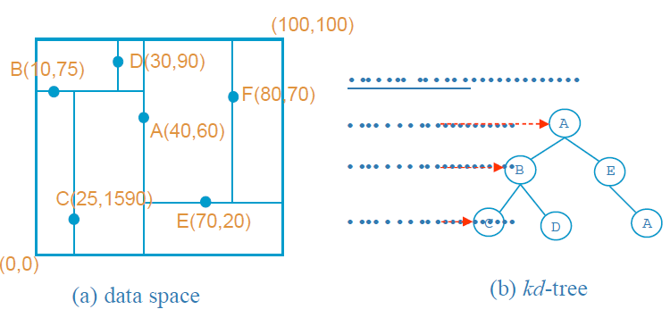

When an item is deleted, a node from the sub-tree must be replaced. Here arises a complication that based on the discriminator in that level, let's call it i, either the node with the smallest i in right sub-tree should be replace or the node with the biggest i in left sub-tree. A non-homogeneous kd-tree was proposed to make this process cheaper.
Kd-Tree has been used a lot in intensive searches, but some variants has been introduced to make a better performance in clustering, searching, storage efficiency and balancing.

Kd-tree Extensions with Paging Capability
Since indexing is too big to be placed in main memory, it has to be paged into disk. Binary search tree paging techniques or tree organization of B-trees could be used to store the kd-Tree.

The K-D-B-Tree

This structure combines properties of kd-tree and B-tree. So, the pages as organizational units are organized in k-d-tree structure. It means benefits of the balanced kd-trees and the I/O efficiency of B-trees are together. It has two basic structures: region page, consist of <region, pageID> pairs, and point page, consist of <point, pageID> pairs. The region page contains the description of its subpages and a reference to those pages. The point pages contains actual data and references to them.

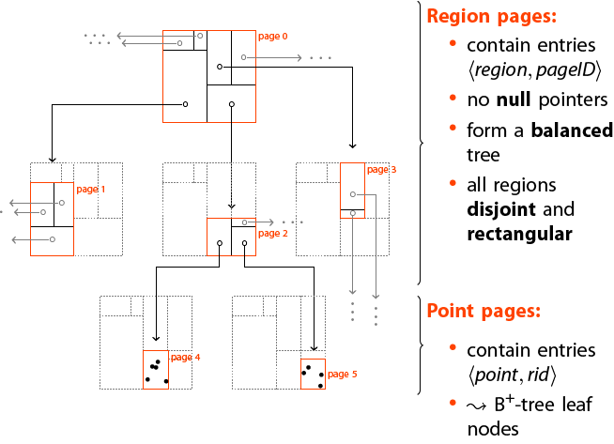

The pagination of the B-tree is integrated in the K-D-B-tree and consequently the tree is height-balanced. Storage efficiency is the trade-off, though, since the downward propagation of splitting, caused by region split, may cause low storage utilization. On the other side, there is no guarantee for minimum space utilization. Since partitions do not overlap, it is not always easy to find disjoint partitions to divide a region. So, those partitions must be split at the same value as parent, even though they do not use the minimum amount of space specified for each node. By this problem the range queries' performance is poor.

The hB-Tree
This is a variation of K-D-B-Tree which could be distinguished by two features: …
Since in a the region split in lower levels result in sparse nodes, hB-Tree (the holey brick Btree) as a multi-attribute index structure is proposed. Data spaces could be holey. It allows the data space associated with a node to be non-rectangular and it uses kd-trees for space representation in its internal nodes. The leaf nodes are known as data nodes and the internal node as index nodes. An index node data space is a union of its child node subspaces which are obtained through kd-tree recursive partitioning. It is height balanced since it is based on the K-D-B-Tree.
Advantages of this structure is removing the sparse nodes of the K-D-B-Tree and reduction of search time and space utilization, since kd-tree is used.
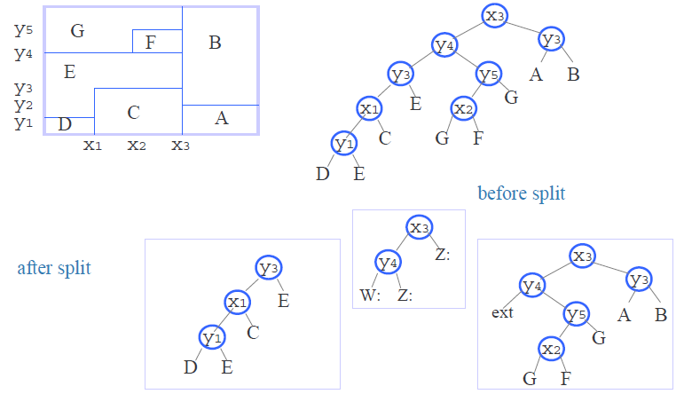
Disadvantages of this structure is that the deletion and splitting of nodes are expensive and also multiple references to a data node will lead to more than one traversal of a path.

Variants of K-D-Tree

Matsuyama’s kd-Tree: This structure is introduced for non-point objects and an extensive duplication strategy is used. The directory is a kd-Tree and a data page is associated for each leaf and those objects which overlaps multiple data spaces are identified in data page and also duplicates. Hence, the data page contains identifiers of the objects totally or partially contained in the corresponding data space.
The point is that this structure is not suitable for large objects since duplication and redundant storage of objects would result in high overhead.

The 4-D-Tree: Indexes rectangular objects using kd-tree by mapping the objects into points in a four-dimensional space. Each 2D rectangle with (x1, y1) and (x2, y2) is considered as a 4D (x1, y1, x2, y2). As kd-tree the discriminators are chosen cyclically from this set. For each node, a discriminator, discriminator value and pointers to two children are stored.
For a region search (qx 1, qx 2, qy 1, qy 2), depending on the discriminator, one of the x1 <= qx2, x2 >= qx1, y1 <= qy2 or y2 >= qy1 has to be done to determine which subtree (or both) has to be searched.
The major problem associated with the 4-d-tree is its intersection search, which can be very costly due to the need for traversal of both subtrees when a query region lies in a subspace that cannot not bounded tightly using the discriminator values.

The skd-Tree

The spatial kd-Tree alters the kd-tree in a way that objects are indexed by their centroid and the minimum bounding box of the object is also stored in the node. This structure is suitable for non-point spatial objects. In a kd-tree the objects which are contained in more than one space, will be referenced more than once. To avoid the duplication virtual subspaces are defined which include the original subspaces. So, each object are placed in the subspace based on its centroid.
With this devision, we just need one more value for each subspace which shows min/max values along the dimension of the discriminator. Therefore, the structure of each node would consist of:
- Two children
- The discriminator and it's value
- The max/ min value of objects left(LOSON)/right(HISON) subspaces along with dimension of the discriminator
The maximum/minimum value of LOSON/HISON the nearest virtual line which bounds the data whose centroid are inside the LOSON/HISON.

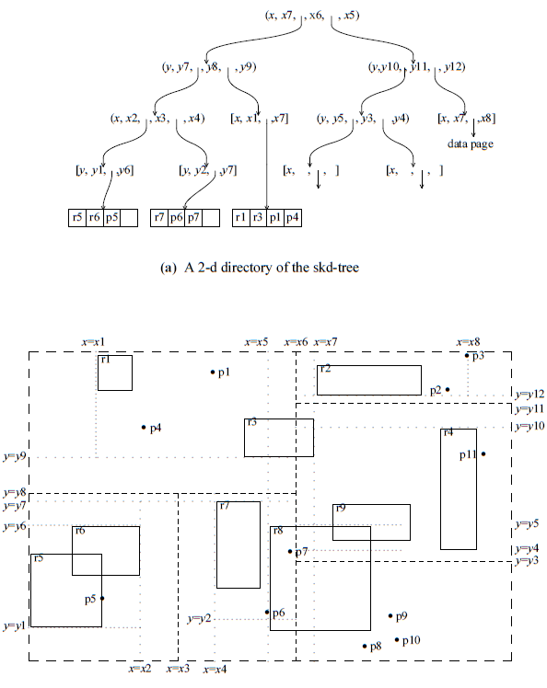

During traversal a rectangular space is associated with each node and materialized such that is tested against the query region if it intersects the region.
(Since the virtual boundary may sometimes bound the objects tighter than the partitioning line, the intersection search takes advantage of the existing virtual boundary to prune the search space efficiently. To further exploit the virtual boundaries, containment search which retrieves all spatial objects contained in a given query rectangle was proposed. During tree traversal, the algorithm always selects the boundaries that yield smaller search space. The direct support of containment search is useful to operators like within and contain. The search rapidly eliminates all objects that are not totally contained in the query region.)
The Sdk-tree is memory-based, not a disk-based, data structure, thus is not suitable for very large databases.

The BD-/GBD-Tree

The LSD-Tree

B-tree based Indexing Technique

The R-Tree

Minimization of both coverage and overlap is crucial to the performance of R-trees.

The R-Tree Variation

R*-Tree
The R*-tree is found to be more efficient than some other variants, and the R-tree using linear splitting algorithm is substantially less efficient than the one with quadratic splitting algorithm. In general, the R*-tree is an improvement over the R-tree at the expense of more expensive insertion.

This structure tries to reduce overlaps between directory rectangles and the area covered by a rectangle, in order to make better performance, since minimum overlaps leads to less number of branches to be traversed in queries and minimum coverage helps to decide on the paths to traverse on higher levels.
R*-Tree does these optimizations with revised node split and also forced insertion which finds a better place for a node that its original place. In R-Tree insertion-build structure is highly suboptimal and insertion and deletion could improves the R-Tree dramatically.
(Using the idea of reinsertion of the R-tree, Beckmann et al proposed a reinsertion algorithm when a node overflows. The reinsertion sorts the entries in decreasing order of the distance between the centroids of the rectangle and the covering rectangle and reinserts the first p (variable for tuning) entries. In some cases, the entries are reinserted back into the same node and hence a split is eventually necessary. The reinsertion will no doubt increase the storage utilization; but it can be fairly expensive when the tree is large. The R*-tree is found to be more efficient than some other variants, and the R-tree using linear splitting algorithm is substantially less efficient than the one with quadratic splitting algorithm. In general, the R*-tree is an improvement over the R-tree at the expense of more expensive insertion.)

The Buddy Tree

(In comparison to previously proposed tree structures such as the K-D-B-tree, the buddy-tree guarantees a more efficient dynamic behavior.Moreover, indirect splits which cause low storage utilization and high insertion costs in the K-D-B-tree, are completely avoided. This structure is
It avoids the downward splitting of the K-DB-tree, the overlapping problem of the R-tree and the dependency of structures upon the insertion of data. The buddy-tree generalizes the buddy system of the grid-file to organize correlated data efficiently, by bounding the data points tightly using the bounding rectangle concepts of the R-tree and organize the directory as in the R-tree. Like grid-files, the non-zero sized data have to be mapped into higher dimension.
An important feature of the buddy-tree is that it does not partition empty data space. Therefore queries, such as partial match queries, where the query region intersects with empty data space, can be performed much faster than by conventional structures partitioning the complete data space.
The following summarizes the design properties of the buddy-tree:
- empty data space is not partitioned
- insertion and deletion of a record is restricted to
- exactly one path
- no overflow pages
- directory grows linear in the number of records
- performance is basicly independent of the sequence of
- insertions
- efficient behavior for insertions and deletions
- very high fan out of the directory nodes)

The Packed R-Tree

In order to minimize storage space, coverages and overlaps in R-Tree, constructing a static tree is proposed. To make this tree, first the objects are ordered along a coordinate. The object with the minimum value then is chosen to find the M nearest objects to that one, and assigns them to a node. Here M is the maximum number of objects that are allowed in a page. This step is repeated until the whole objects are assigned to a node. The bounding box of the leaf nodes are higher level objects. These are also ordered and assigned to the nodes. The process repeats until the number of the remained nodes is less than M. If so, they are assigned to the root.
The main objective of the algorithm is to reduce the storage space, the coverage and overlap of rectangles, in order to improve the search efficiency.

R⁺-Tree

This structure is a compromise between the R-tree and the K-D-B-tree, to solve the overlapping problem of covering rectangles. It has just some difference:

- Nodes of an R+-tree are not guaranteed to be at least half filled.
- The entries of any intermediate (internal) node do not overlap.
- An object identifier may be stored in more than one leaf node.

The duplication of the objects in the tree avoids overlappings and consequently leads to less path traversals in point queries.
On the other hand there is some disadvantages: it might be bigger that R-Tree as a result of duplications, and the construction and maintenance are more complex that R-Tree or other variants.
Also, in insertion cases into the tree a case would happen that the covering rectangles of some entries can prevent each other from expanding to include the new object. In other words, some space ("dead space") within the current node cannot be covered by any of the covering rectangles of the entries in the node. If the new object occupies such a region, it cannot be fully covered by the entries. When a new object cannot be fully covered, one or more of the covering rectangles are split. This means that the split may cause the children of the entries to be split as well, which may further degrade the storage efficiency.
In performance study, in the comparison between R-trees and R+-trees, it is found that the R+-tree requires much more splits, especially for large data objects, but lesser splits for smaller data objects.
In general, the query efficiency tests show that R+-trees perform better for smaller objects and slightly worse off for larger objects.

The Cell Tree

The cell tree introduces a structure to overcome the overlapping bounding rectangle problems of R-trees and the "dead space" (empty space) problems of R+-trees. Partitioning is done in a recursive way, but not necessarily with rectangles. Instead, the regions are polyhedral, as bounding polygons. Subspaces do not overlap.

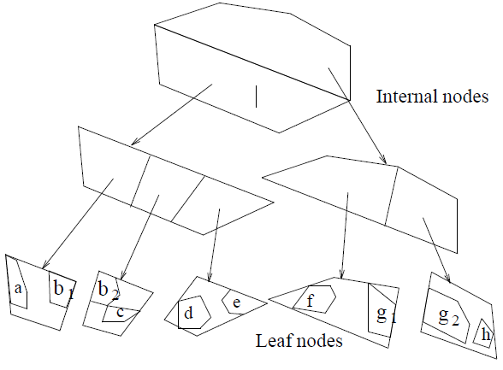

Like R+-Tree, objects might be represented in more than one leaf node. One problem with such an instruction which duplicates the objects is that each new object may be divided into multiple pieces in order to store them in a tree where internal node bounding polygons do not overlap. Specially in populated DBs.
(Each split of a node leads to a decrease in the node data space but to an increase in the number of nodes per object. To overcome the fragmentation and duplication problems, Gunther and Noltemeier proposed to store oversized objects which may greatly increase the number of object identifiers being stored in the leaf nodes in separate "oversize shelves". These oversize shelves are data nodes linked to internal nodes in the cell-tree, in one way, causing the tree to be not height-balanced. The placement of a new object in the subtree or oversize shelf requires some optimization. The oversize page shelf can be overflowed and a split on this shelf is necessary.)

Quad-tree Based Structures

It is organized in a way similar to the region quad-tree. A region is recursively partitioned until the resulting quadrants do not contain any rectangle. During the subdivision, all rectangles that intersect with either of the two partitioning lines are associated with the partitioning lines. The rectangles that are associated with a quadrant must not belong to any ancestor quadrant. It is assumed that no two rectangles overlap.

http://docs.marklogic.com/guide/search-dev/geospatial#chapter
http://docs.marklogic.com/guide/search-dev/lexicon#id_90832
http://docs.marklogic.com/cts/geospatial
http://docs.marklogic.com/cts/geospatial-lexicon

